

Emergency Incident Plan

for

Works on State Controlled Roads

Table of contents
1. Preface 1
1.1 Scope 1
1.2 Principle 1
1.3 Purposes of this Plan 1
2. Project details 2
2.1 Overview 2
2.2 Major hazards 2
2.3 Pre-emptive actions to minimise or prevent any risk of harm 3
2.4 Pollution inventory 5
2.5 Safety equipment and storage location 5
2.6 Minimising harm to persons on the premises 6
3. Incident management 7
3.1 Pollution incident 7
3.2 Material harm 7
3.3 Duty to notify management personnel 7
3.4 Key site contacts 7
4. Incident Response Procedure 8
4.1 Response protocol 8
4.2 Post incident-notification and reporting procedures 8
5. Reporting, review and training 10
5.1 Training 10
5.2 Testing, review and update 10
5.3 Review of the Plan 10
5.4 Plan Availability 11
6. Roles and responsibilities 12

Appendices
Appendix A Emergency Action Plan
Appendix B Spill Response Procedure
Appendix C Testing and review registers

Preface

Scope
This Emergency Incident Plan (EIP) details Council’s management of safety and environmental emergencies. This sub plan is part of Council’s Council System Management Plan (CSMP) and Project Specific Plan (PSP). It should be read in conjunction with these documents.
It deals with:
- Preparation for emergencies; and
- Responding to and managing emergencies.
The Plan addresses the requirements of the Protection of the Environment Operations Act 1997 (PoEO Act) for a Pollution Incident Response Management Plan (PRIMP), Roads and Maritime Services (TfNSW) specifications G22 Clause 4.9. and G36 Clause 3.8.

Principle
In the event of an emergency, the safety of workers (Council and TfNSW personnel, contractors) and the public takes priority. Once the safety of workers and the public has been established, the next consideration is the minimisation of damage to the environment.

Purposes of this Plan
This EIP aims to make workers aware of the requirements for the timely planning and safe response to incidents in order to minimise damage to the environment.

Project details

Overview
The Project involves routine maintenance, works orders and construction projects on state controlled roads within the Singleton Council area.

Major hazards
The following potential hazards to human health and the environment may occur from incidents on the site such as:
- Implosion, explosion or fire;
- Escape, spillage or leakage of hazardous substances;
- Leak/spillage of contaminated stormwater;
- Excessive/harmful air emissions (dust, smoke, fumes, etc.);
- Truck collision / spill on site;
- Flooding during construction; and
- Moving large volumes of soil/pavement materials.
Possible circumstances or events that could increase the likelihood of major hazards occurring are listed in Table 2-1.

Table 2-1: Major hazards and circumstances that could increase the likelihood of their occurrence
Major hazards | Circumstances or events that could increase the likelihood
Implosion, explosion or fire. | - Uncontrolled release of gas.
Escape, spillage or leakage of hazardous substances. | - Failure of storage tanks.  - Failure of bunded areas.
Leak/spillage of contaminated stormwater. | - Failure of storage tanks.
Excessive/ harmful air emissions (dust, smoke, fumes, etc.). | - Using equipment that doesn’t comply with emissions standards.  - Not watering stock piles/exposed areas.  - Strong winds.
Truck collision / spill on site. | - Unsafe driving (e.g. speeding).
Flooding during construction | - Unexpected storms.
Moving large volumes of soil/pavement materials | - High wind conditions. Unexpected storms.

Pre-emptive actions to minimise or prevent any risk of harm
Table 2-2 contains a list of the key pre-emptive actions applied on site to minimise the risk of the potential hazards and incidents.
In addition to the controls listed in Table 2-2 all workers undergo appropriate safety and environmental training at the site induction and regular toolbox talks and wear appropriate Personal Protective Equipment (PPE).
Safety equipment and other devices used to contain or control pollution incidents are included in Section 2.5.
Table 2-2: Major hazards and pre-emptive actions
Hazard | Pre-emptive action
Implosion, explosion or fire. | - Fire extinguishers suitable for control of oil/fuel fires will be available on all mobile plant, offices and vehicles.  - Any flammable goods on site will be stored in small volumes in individual containers and in storage that meets Australian standards for hazardous goods and storage.  - Workers on site will be familiar or trained in the use of fire-fighting equipment.  - Firefighting equipment will be maintained regularly.  - Fire detection and control systems will be in place and regularly inspected.
Escape, spillage or leakage of hazardous substances. | - An appropriate spill kit is to be kept on site at all times and any spillage is to be immediately cleaned up. Major maintenance shall be avoided as far as practicable and will be conducted at the Council works depot. If required on site, it shall be undertaken in a designated area with appropriate bunding and surface protection to prevent contamination.  - Vehicles and plant on site will be inspected and maintained as required to minimise leaks and potential spills (Refer Plant Start up checks).  - All fuel, oil and chemicals stored on site will be stored in accordance with AS 1940 in bunded areas on site to prevent leaching, leaking or other transfer of material into stormwater drains.  - All fuels, chemicals and liquids a minimum of 50 metres away from waterways, ephemeral creeks and drainage lines.  - Safety Data Sheets for all hazardous substances stored on site will be available on site.  - Material spillage on roads and pathways is to be cleaned up immediately.
Leak/spillage of contaminated stormwater. | - All erosion and sediment control (ESC) measures are to be inspected on a regular basis and within 24 hours of 10mm rainfall events and any rectification measures undertaken immediately.  - Remove sediment from ESCs once 30% of the capacity of the control is reached.
Excessive/ harmful air emissions (dust, smoke, fumes, etc.). | - During periods of high winds, cease activities when unacceptable levels of visible dust emissions are moving off-site, until adequate control measures are implemented or conditions improve.  - Regularly inspect and maintain plant and equipment.  - All plant and machinery will be turned off when idling.  - Stockpiled material would be watered as required. Long term stockpiles will be sealed to prevent dust erosion.  - Haulage vehicles carrying materials will be appropriately covered  - Long term stockpiles will be sealed to prevent dust erosion.
Truck collision / spill on site. | - Traffic Management Plan (TMP),including speed reductions, will be in place during construction. Speed reductions will reduce the likelihood of a vehicle crash.  - An appropriate spill kit is to be kept on site at all times and any spillage is to be immediately cleaned up.
Flooding during construction | - All ESC measures are to be inspected on a regular basis and within 24 hours of 10mm rainfall events and any rectification measures undertaken immediately.  - Remove sediment from ESCs once 30% of the capacity of the control is reached.
Moving large volumes of soil/pavement materials | - During periods of high winds, cease activities when unacceptable levels of visible dust emissions are moving off-site, until adequate control measures are implemented or conditions improve.

Pollution inventory
The primary hazardous materials and chemicals (including fuels) used and stored on site and the maximum quantity to be stored on site are listed in Table 2-3. Potential pollutants will be stored in a bunded area when not in use within the site compound areas (Refer to Site Plan -PSP Att. 12.3). Safety equipment and safety data sheets will be located within the site compound area.
Table 2-3: Potential pollutants and quantity
Potential pollutants | Maximum quantity stored on site | Storage location (also refer to the Site Plan - PSP Att. 12.3)
Diesel fuel | 500 litres | - Plant.  - Site compound (mobile refuelling/fuel trailers).
Oil and lubricant | 20 litres | - Plant.  - Site compound (mobile refuelling/ maintenance vehicles).
Grease | 5 litres | - Plant.
Hydraulic oil | 20 litres | - Plant.  - Site compound (mobile refuelling/ maintenance vehicles including refuelling).
Survey and marking paint | 5 litres | - Site compound.  - Work Vehicles (Ute or Truck).

Safety equipment and storage location
A summary of the safety equipment to be kept on site and the location of storage on the premises is presented in Table 2-4 and is shown on the Site Plan (Refer PSP Att. 12.3).
Table 2-4: Safety equipment and location to be stored on site
Safety equipment | Location of safety equipment
Fire extinguishers suitable for control of oil/fuel fires. | - On all plant  - Depot/site compound
Mobile spill kit. | - Depot/site compound
Bund equipment. | - Temporary refuelling and overnight plant parking areas  - Plant wash down areas
First aid kit. | - Depot/site compound  - In work vehicles/trucks

Minimising harm to persons on the premises
An Emergency Action Plan (Refer Appendix A) has been developed and will be implemented for the Project. The Site Plan (Refer PSP Att. 12.3) includes emergency muster points, first aid kit locations, and Table 3-1 lists emergency personnel names and phone numbers.

Incident management

Pollution incident
A pollution incident is defined in the POEO Act as:
“an incident or set of circumstances during or as a consequence of which there is or is likely to be a leak, spill or other escape or deposit of a substance, as a result of which pollution has occurred, is occurring or is likely to occur.
It includes an incident or set of circumstances in which a substance has been placed or disposed of on premises, but it does not include an incident or set of circumstances involving only the emission of any noise.”
Potential pollution incidents for the Project are described in Section 2.2.

Material harm
A pollution incident is required to be notified if there is a risk of ‘material harm to the environment’, which is defined in section 147 of the POEO Act as:
“(i) it involves actual or potential harm to the health or safety of human beings or to ecosystems that is not trivial, or
(ii) it results in actual or potential loss or property damage of an amount, or amounts in aggregate, exceeding $10,000 (or such other amount as is prescribed by the regulations), and
(b) loss includes the reasonable costs and expenses that would be incurred in taking all reasonable and practicable measures to prevent, mitigate or make good harm to the environment.”

Duty to notify management personnel
All workers are responsible for alerting management personnel (Works Overseer, Road Project Officer or Project Coordinator) to all incidents or hazards which may result in an incident, regardless of the nature or scale.

Key site contacts
The contact details for key personnel who are responsible for activating this EIP, and managing the response to an incident, are provided in Table 3-1 below. Specific roles and responsibilities are outlined in Section 6.
Table 3-1: Key site contacts
Name | Role | Mobile Number
Conor Byrne | Civil Operations Coordinator (24 hour) | 0419629017
Arnie Redemski | Project Coordinator (24 hour) | 0417687997
Roger Crawford | Road Project Officer

Incident Response Procedure

Response protocol
As discussed in Section 3.3, the notification of an incident is the responsibility of all workers.
In the event of an incident, the Emergency Action Plan (Refer Appendix A) must be implemented. Alternatively, in the event of a chemical spill, the Spill Response Procedure (Refer Appendix B) can be used.

General clean-up procedure
The following general clean up procedure is to be followed:

- Assessment - Assess best clean up procedures for each incident based on the pollutant and site issues.
- Remedial Action - Remove contaminated soil, wastewater and used spill equipment to an appropriate place within a licensed waste facility.
- Ongoing Actions - Following an incident the following must be undertaken:
- Undertake further monitoring/ testing if required;
- Organise restocking of spill equipment;
- Complete reports to Authorities, as necessary; and
- Implement corrective actions to avoid reoccurrence.

Post incident-notification and reporting procedures

Incident reporting to the SafeWork
If there is a serious injury or illness, a death or a dangerous incident, the incident must report it to SafeWork immediately on 13 10 50. The incident site must be preserved until an Inspector attends (or the inspector or regulator directs otherwise).
Notifiable incidents under the work health and safety legislation are:
- the death of a person;
- a serious injury or illness of a person; or
- a potentially dangerous incident.

Incident reporting to the EPA
The notification of environmental incidents under this EIP is only required for those incidents causing or threatening to result in material environmental harm (a material harm incident) as defined by the POEO Act (Refer Section 3.1).
Immediately notify the EPA following a notifiable event, and within 7 days submit a detailed report including the following information:
- Describe the date, time, and nature of the incident;
- Identify the cause (or likely cause) of the incident;
- Describe what action has been taken to date; and
- Describe the proposed measures to address the incident.
If any of the information was not known at the time of initial reporting of the pollution incident to any of the Authorities, that information should be notified to the Authorities immediately after it becomes known.
Council personnel will:
- Liaise with the EPA regarding appropriate actions to be taken to control, manage and mitigate the pollution;
- Work co-operatively with the EPA and any other relevant authorities to clean-up any pollution;
- Notify the community of the results of ongoing monitoring of the pollution; and
- Consult any owners or occupiers in the vicinity of the site regarding any off-site actions to be taken which may impact on their properties.

Notification of pollution incident to community / local landholders
The site is located on the state controlled road network within the
Singleton Council area as described in the PSP. Council will consult with the community when necessary throughout the Project.
Any incident causing or threatening material harm to the environment will be communicated to all people likely to be adversely affected by the incident. Communication with these people will be made as soon as practicable following an Incident as well as on an ongoing basis until the incident has been fully controlled and any harm caused as a result of the incident has been rectified.
Council will contact people affected by a Incident either by telephone, letterbox drop or ‘doorknocking’. Notifications will also be made, if deemed necessary, on the Council website. The method and content of any communication will depend on the pollution incident and the actions required to protect human health. For example, advice may be given to avoid the use of water in creeks affected by the discharge of a pollutant to a waterway.

Reporting, review and training

Training
All new staff, contractors and visitors to the premise will undergo a site induction. This training will ensure all personnel are aware of this EIP and the response procedure to an emergency incident.
For workers who are in contact and/or work with dangerous goods and/or hazardous materials at the site, will be provided with specific safety and environmental training.
Targeted training exercises will also be undertaken for those workers in regard to the safe and correct use of all spill clean-up equipment or pollution prevention structures on site and the safe handling and legal disposal of contaminated materials and wastes resulting from an incident.
Refresher training on this EIP will also be provided to all workers if there are any amendments, in addition to periodic refresher training on an annual basis at the yearly site induction.
Site induction records are kept in the PSP Attachment 14.1 and a training register is kept in the PSP Attachment 12.4.

Testing, review and update

Testing of the Plan
Testing of the EIP will be coordinated by the Project Environmental Representative (PER) and/or Project Safety Representative (PSR) to check that the information is accurate and current and that the EIP is capable of being implemented in a workable and effective manner.
Testing is taken to be either a desktop test or an emergency incident drill. The frequency of testing is specified in section 5.3 below and in the Internal Audit Schedule (refer PSP Attachment 6.1.) Testing will include all components of the EIP, including training requirements.
Records of testing must be provided in the table presented in Appendix C of this EIP. Information to be retained regarding EIP testing includes:
- The manner in which the test was undertaken;
- Dates when the EIP has been tested;
- The person who carried out the testing; and
- Summary of the training exercise.

Review of the Plan
A review of the EIP will occur in the following circumstances:
- Every 12 months. Contact details in this document must be kept current at all times;
- A review of the EIP should be conducted if a training exercise proves the EIP inadequate or improvements are recommended; and
- Within one month of the date of any material harm pollution incident that occurs in the course of an activity to which the EPL relates. This review will be undertaken in light of the incident, to determine if the information included in the EIP is accurate and up to date and the EIP is still capable of being implemented in a workable and effective manner.
The review of the EIP will include the following information:
- Date of the review;
- The name of the person who reviewed the EIP; and
- A summary of changes made to the EIP.
A review register form is included in Appendix C.

Plan Availability
This EIP is stored and made available in accordance with Councils Records Management Plan (Refer to CSMP Section 6).
A hard copy of the EIP is available at the Singleton office for all workers responsible for implementing the EIP.
The Emergency Action Plan (Refer Appendix A) and Spill Response Procedure (Refer Appendix B) are printed and available on the wall of the site office for easy access for all workers working on the site.
The EIP will be made available to an EPA or SafeWork Authorised Officer on request.

Roles and responsibilities
Role | Responsibility
Director Planning and Infrastructure/ Manager Infrastructure Services | - Provide adequate resources for the implementation of this EIP.
 | - IMMEDIATELY implement this EIP when notified that an Incident has occurred onsite, including notifications as per Appendix A.
 | - Provide written Pollution Incident report to EPA within 7 days on an incident occurring.
Civil Operations Coordinator / Project Coordinator | - IMMEDIATELY implement this EIP when notified that an Incident has occurred onsite, including notifications as per Appendix A.
 | - Ensure this EIP and contact details are kept up to date.
 | - Ensure current version of this EIP is available as a hard copy kept at the office (in a prominent, readily accessible location).
 | - Ensure that all workers have been inducted in the requirements of this EIP and procedures.
Project Safety and Environmental Representatives | - IMMEDIATELY implement this EIP when notified that Incident has occurred onsite, including notifications as per Appendix A.
 | - Monitor that works activities are being undertaken in accordance with the pre-emptive measures in this EIP.
 | - Undertake regular inspections to assess storage facilities and safety and pollution control equipment.
 | - Ensure that work areas have spill kits available.
 | - Annually test this EIP.
 | - Review and update this EIP following each test and record the outcomes.
Road Project officer / Works Overseer | - IMMEDIATELY implement this EIP when notified that a Incident has occurred onsite, including notifications as per Appendix A.
 | - Ensure that work areas have spill kits available.
 | - Ensure all chemicals, hydrocarbons and hazardous substances are stored and handled appropriately.
 | - Report any potential hazards to Management.
 | - Evacuate area and/or assist in clean-up operations.
Workers | - IMMEDIATELY report all Pollution Incidents to the person responsible for the site i.e. the Overseer.
 | - Ensure all chemicals, hydrocarbons and hazardous substances are stored and handled appropriately.
 | - Report any potential hazards to the Overseer.
 | - Evacuate area and/or assist in clean-up operations.

- Emergency Action Plan
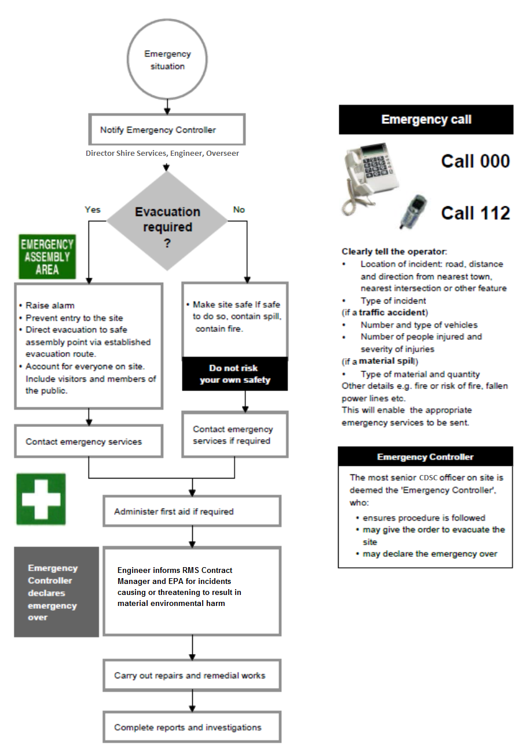

Project Officer contacts SafeWork and/or EPA for notifiable incidents. Project Officer also informs TfNSW Contract Manager of SafeWork and EPA notifiable events.

- Spill Response Procedure

- Testing and review registers
Testing Register
Date | Manner of testing | Tested by | Testing outcomes

Review Register
Version | Date | Reviewed By | Summary of changes
1.0 | 2 Jan 2020 | Arne Redemski (Contracts Engineer) | Initial release

